**PRAKTIKUM 8 TRANSFORMASI CITRA**

Nama : Muhammad Baehaqi

NIM : 1207070134

**Latihan 1 Transformasi Twirl**

**Source Code :**

import matplotlib.pyplot as plt

from skimage.transform import swirl

import cv2

image = cv2.imread("jisoo.jpg")

swirled = swirl(image, rotation=0, strength=20, radius=200)

fig, (ax0, ax1) = plt.subplots(nrows=1, ncols=2, figsize=(8, 3), sharex=True, sharey=True)

ax0.imshow(image, cmap=plt.cm.gray)

ax0.axis('off')

ax1.imshow(swirled, cmap=plt.cm.gray)

ax1.axis('off')

plt.show()

**Hasil :**

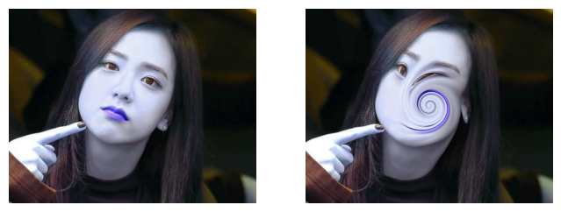

**Latihan 2 Translation**

**Source Code :**

import cv2 as cv

import numpy as np

import matplotlib.pyplot as plt

image = cv.imread("jisoo.jpg")

h, w = image.shape[:2]

half_height, half_width = h//6, w//10

transition_matrix = np.float32([[1, 0, half_width], [0, 1, half_height]])

img_transition = cv.warpAffine(image, transition_matrix, (w, h))

plt.imshow(cv.cvtColor(img_transition, cv.COLOR_BGR2RGB))

plt.title("Translation")

plt.show()

**Hasil :**

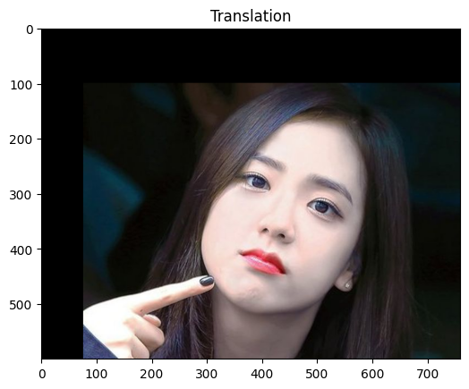

**Latihan 3 Rotation**

**Source Code :**

import cv2 as cv

import matplotlib.pyplot as plt

image = cv.imread("jisoo.jpg")

h, w = image.shape[:2]

rotation_matrix = cv.getRotationMatrix2D((w/2,h/2), -180, 0.7)

rotated_image = cv.warpAffine(image, rotation_matrix, (w, h))

plt.imshow(cv.cvtColor(rotated_image, cv.COLOR_BGR2RGB))

plt.title("Rotation")

plt.show()

**Hasil :**

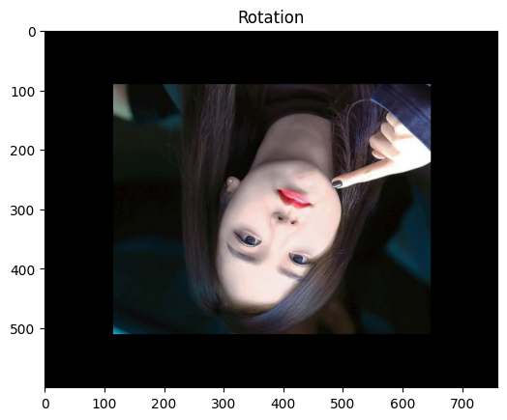

**Latihan 4 Interpolation**

**Source Code :**

import mahotas as mh

import numpy as np

from pylab import imshow, show

regions = np.zeros((8,8), bool)

regions[:3,:3] = 1

regions[6:,6:] = 1

labeled, nr_objects = mh.label(regions)

imshow(labeled, interpolation='nearest')

show()

**Hasil :**

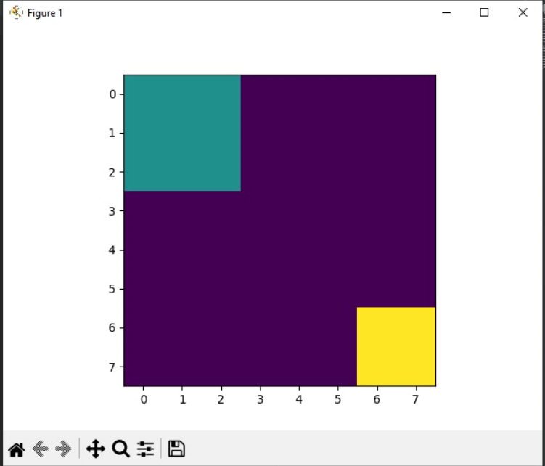

**Latihan 5 Skala Interpolation Miring**

**Source Code :**

import cv2 as cv

import numpy as np

import matplotlib.pyplot as plt

image = cv.imread("jisoo.jpg")

fig, ax = plt.subplots(1, 3, figsize=(14, 6))

image_scaled = cv.resize(image, None, fx=0.15, fy=0.15)

ax[0].imshow(cv.cvtColor(image_scaled, cv.COLOR_BGR2RGB))

ax[0].set_title("Linear Interpolation Scale")

image_scaled_2 = cv.resize(image, None, fx=2, fy=2, interpolation=cv.INTER_CUBIC)

ax[1].imshow(cv.cvtColor(image_scaled_2, cv.COLOR_BGR2RGB))

ax[1].set_title("Cubic Interpolation Scale")

image_scaled_3 = cv.resize(image, (200, 400), interpolation=cv.INTER_AREA)

ax[2].imshow(cv.cvtColor(image_scaled_3, cv.COLOR_BGR2RGB))

ax[2].set_title("Skewed Interpolation Scale")

**Hasil :**

